**Year 12 Physics INVESTIGATION – Wave Properties 2022**

**Research**

**Assessment type:** Science inquiry – Investigation and analysis

**Conditions**

* The task consists of a research period followed by an in-class validation under test conditions
* Time allowed for research: 2 weeks
* The mark awarded for the task will come entirely from the in-class validation to be held at the end of the research period
* All research material (hand-written, printed or photo-copied) may be used during the validation
* Research material will not be required to be submitted as part of the assessment
* The Year 12 Physics Data and Formula sheet may be used during the validation
* Scientific calculator permitted during validation

**Task weighting**

7.5% of the school mark for this pair of units

PART 1 – Double Slit Interference Patterns

As we saw in our notes on Wave Particle Duality and the Quantum Theory, when light or particles pass through two slits, an interference pattern is produced.

Visit <http://www.studyphysics.ca/newnotes/20/unit04_light/chp1719_light/lesson58.htm>

to see how the following two formulas relate to the interference pattern produced by two slits:

$λ$ = $\frac{xd}{nL}$

$λ$ = $\frac{d sin θ}{n}$

Note: Don’t read the last part of the above webpage, which refers only to single slit interference patterns.

The above formulas may be used equally with light or particles. In the latter case, use the de Broglie wavelength for $λ$.

(You are welcome to research other websites and sources on this topic if you wish.)

PART 2 – Snell’s Law

Visit <https://www.physicsclassroom.com/class/refrn/Lesson-2/Snell-s-Law>

to find out about Snell’s Law, which relates to the passage of light from one medium to another. You will see the formula

$n_{1}\sin{θ_{1}=n_{2}\sin{θ_{2}}}$.

Also visit <https://en.wikipedia.org/wiki/Refractive_index>

(just the first two paragraphs) to find out what *refractive index* (e.g. $n_{1}$ and $n_{2}$ above) means:

$n$ = $\frac{c}{v}$.

(You are welcome to research other websites and sources on this topic if you wish.)

**Year 12 Physics INVESTIGATION – Wave Properties 2022**

**Validation**

NAME:

*Total Marks: 34 Time Allowed: 45 minutes*

(Formula sheet, research notes and scientific calculator permitted)

**Question 1 (8 marks)**

In a double-slit experiment, Anna uses blue light of wavelength 465 nm, a slit separation of 0.0400 cm and a slit-screen distance of 55.0 cm.

1. How many bright bands will Anna see inside the central 10.0 cm of the screen? [5]

Consider the line perpendicular to the screen and joining the middle of the screen to the midpoint between the slits.

1. At what angle (in degrees) to this line would Anna see the 3rd-order fringe? [3]

**Question 2 (7 marks)**

Brock is conducting a two-slit experiment in which he fires electrons at the slits at a speed of 7.90 × 106 ms-1.

1. If electrons are particles, what should he see on the screen? [1]
2. What will he actually see on the screen, and what does it suggest about the nature of electrons? [2]
3. What is the de Broglie wavelength of the electrons? [3]
4. How far from the central fringe is a 5th-order fringe if the screen distance is 1.00 × 104 times the slit width? [3]

**Question 3 (7 marks)**

A certain type of glass has a refractive index 1.52. A yellow light ray of wavelength 582 nm enters the glass (from air). Find the ray’s

1. frequency in the glass, [3]
2. speed in the glass, [2]
3. wavelength in the glass. [2]

**Question 4 (10 marks)**

The diagram below shows a ray of light in air entering an isosceles triangular glass prism parallel to the base of the prism and 10.0 cm from the apex of the prism:

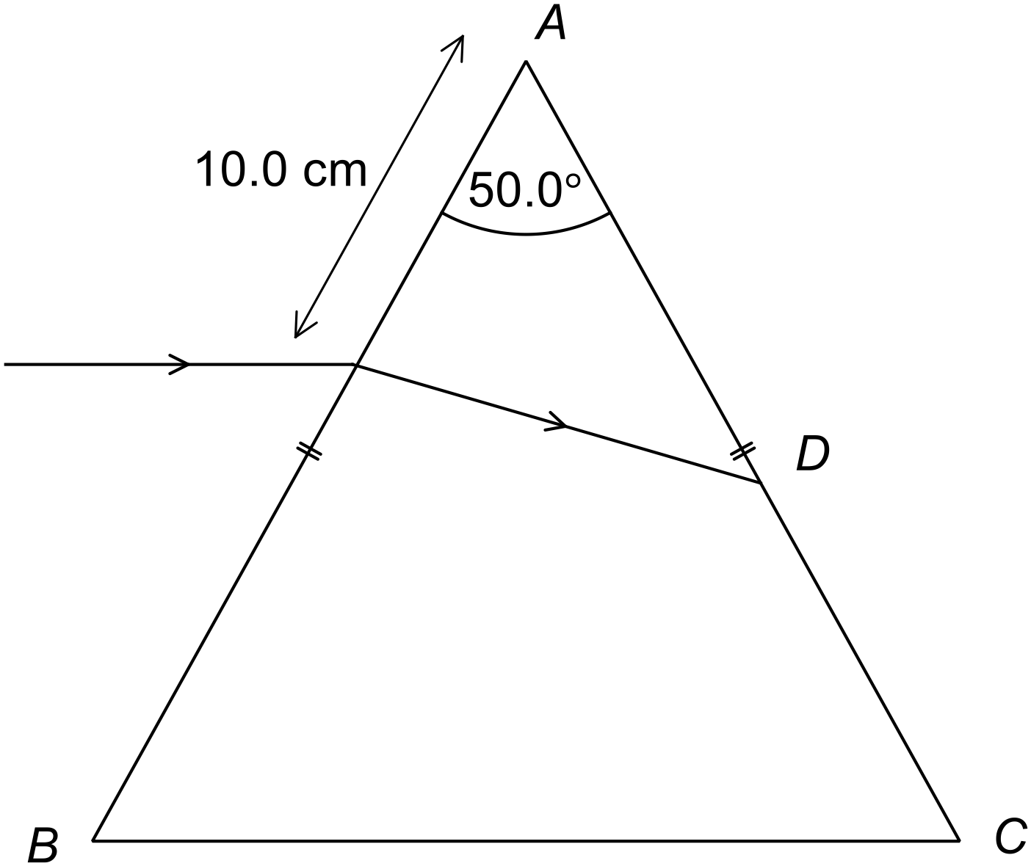

The refractive index of the glass is 1.50.

1. Find the distance *AD*. [8]

*(More working space for part (a))*

1. Draw and label the normal at point *D*, and also draw the emerging ray from point *D*. (No calculation required.) [2]

*– End of Questions –*